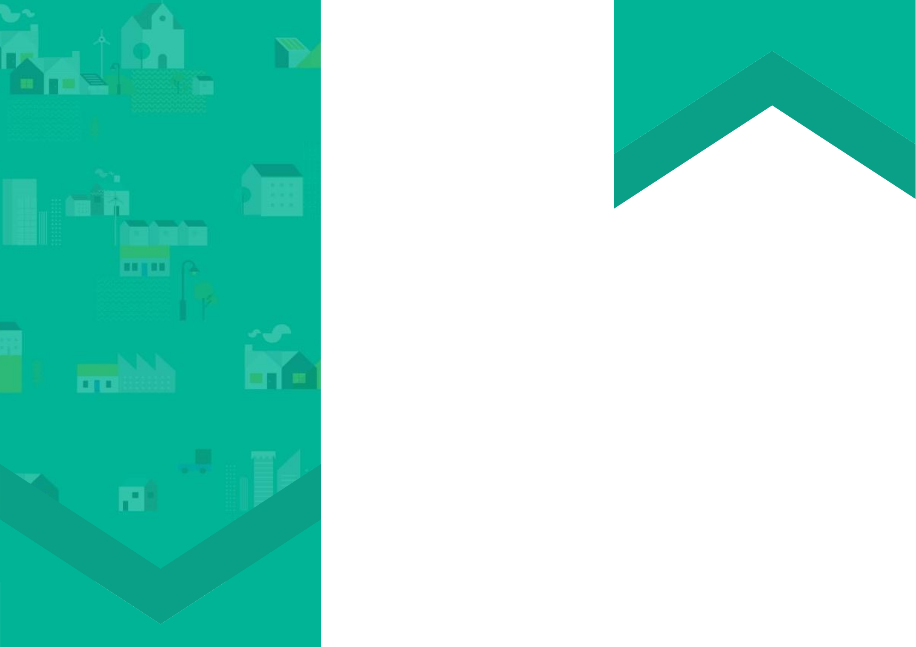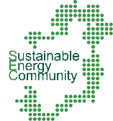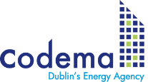

**Introduce your SEC:**

(Insert your SEC name here) has been up and running since X and has successfully recruited X members.

**Share your achievements:**

So far **(Insert your SEC name here)** has (**insert details of your progress so far**: e.g. completed the “Learn” stage of the 3-step process, achieving x, y, z. We have now graduated to the “Plan” stage and will be engaging in an Energy Master Plan).

“

“

***Feel free to Include a quote here from a member of your team or your mentor to further personalise this flyer***

**Encourage new members:**

Insert a call to action here e.g. If you are interested in learning more about (Insert SEC name here), feel free to come along to one of our meetings. We are always delighted to welcome new members.

For more information and to join our enthusiastic team of volunteers contact us on: (email or phone number)

* Insert your SEC name/member/mentor

**JOIN OUR COMMUNITY**

A Sustainable Energy Community (SEC) is a community in which everyone works together to develop a sustainable energy system for the benefit of the community.

**About the (Insert your SEC name here) Sustainable Energy Community**

**www.codema.ie/sec**