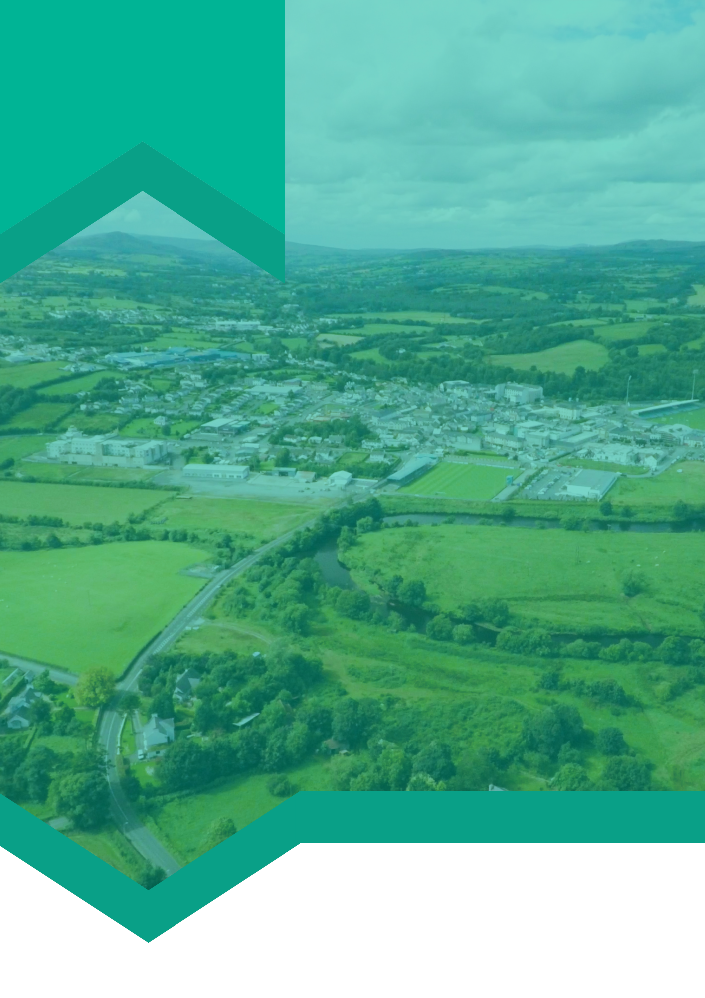

**Insert SEC logo here**

**Case Study: (Insert name of SEC here)**

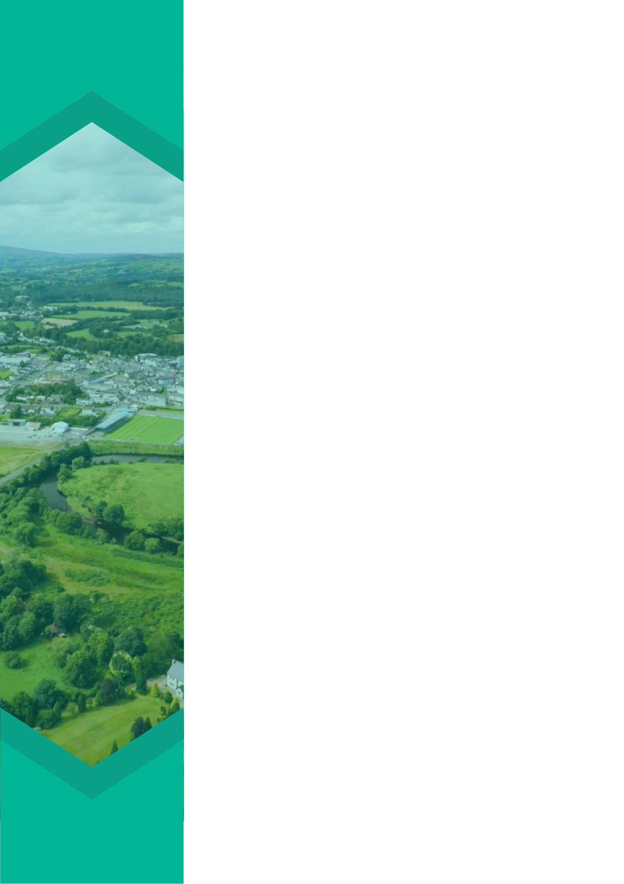

**Project Description**

**For further information on this project please contact:**

Insert text here to explain the project further. Did you receive funding? Who were the stakeholders involved? What was involved in the project? What did you set out to achieve? Why was this project of particular importance to your SEC?

**Insert a quote here from a member of your SEC/ your mentor or relevant stakeholder involved in the project**

Insert text here to explain the background to the specific project you want to highlight within your SEC. What is the project? Where and when did it take place? What was the situation prior to project implementation and completion?

**Project Background**

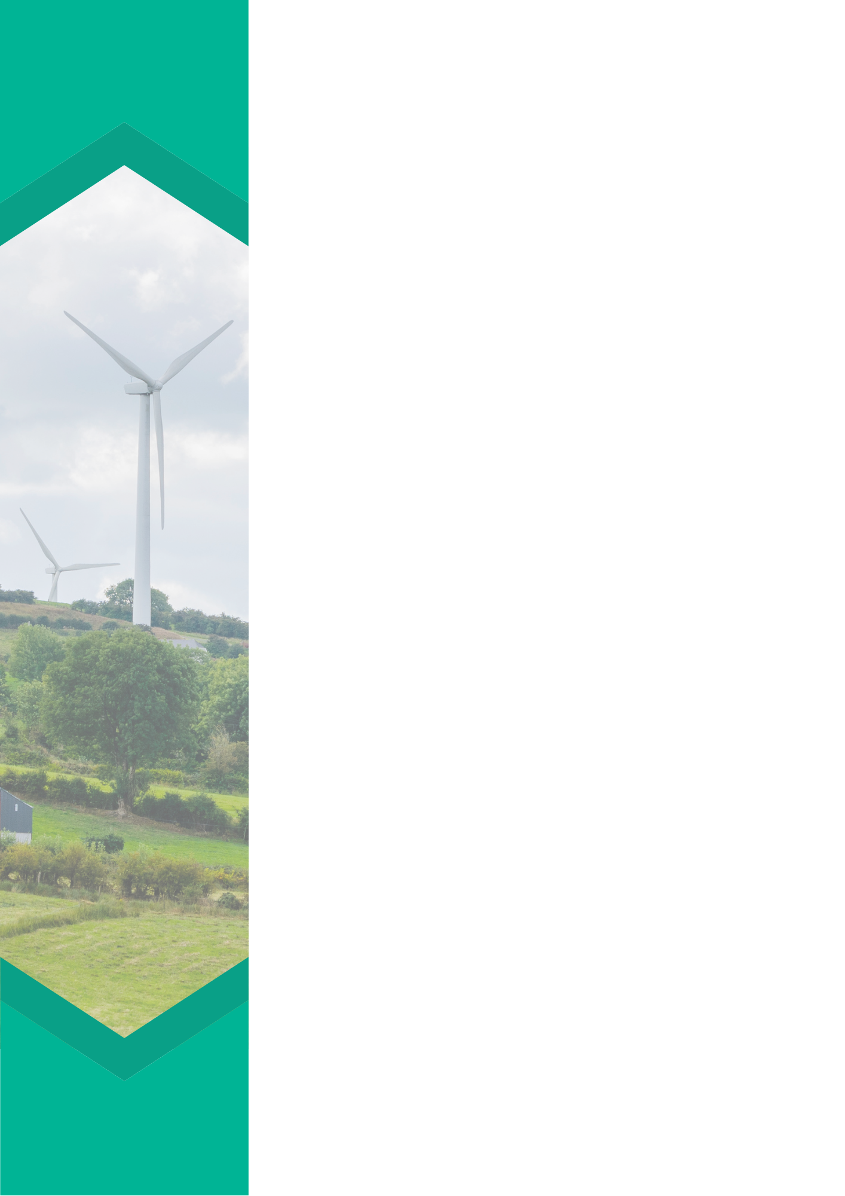

Use this space to discuss the conclusions and next steps of the project and perhaps insert a couple of pictures from your project.

* **Annual Energy Savings:**
* **Annual Cost Savings:**
* **Project Cost:**
* **Payback:**

Use this space as an opportunity to detail the results of the project. What did this project achieve? How has your community improved as a result?

**Follow our progress on (insert social media handles).**

Insert picture here

Insert picture here

**Results:**

**For further information on this project please contact:**

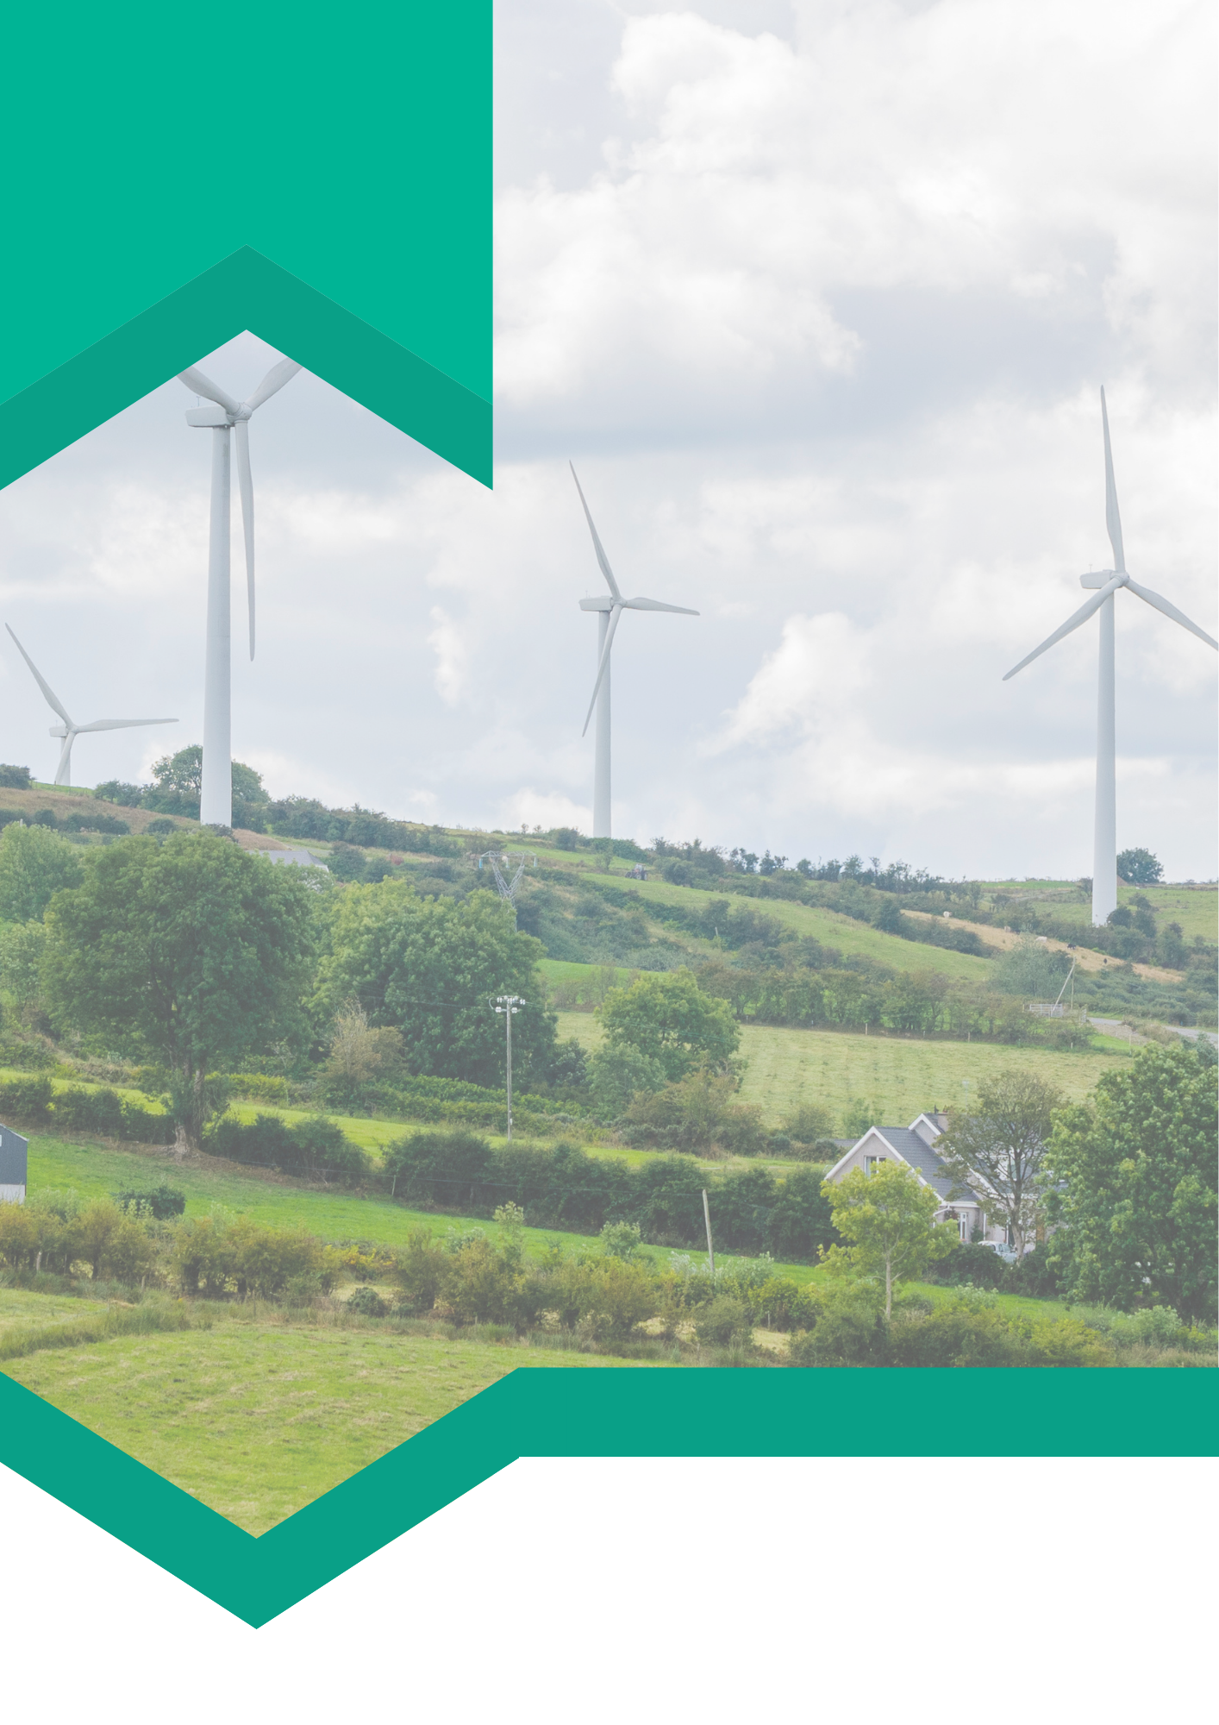

**Insert SEC logo here**

**For more news, updates and information on the Sustainable Energy Community Programme visit www.codema.ie/sec**



**Alternative template**

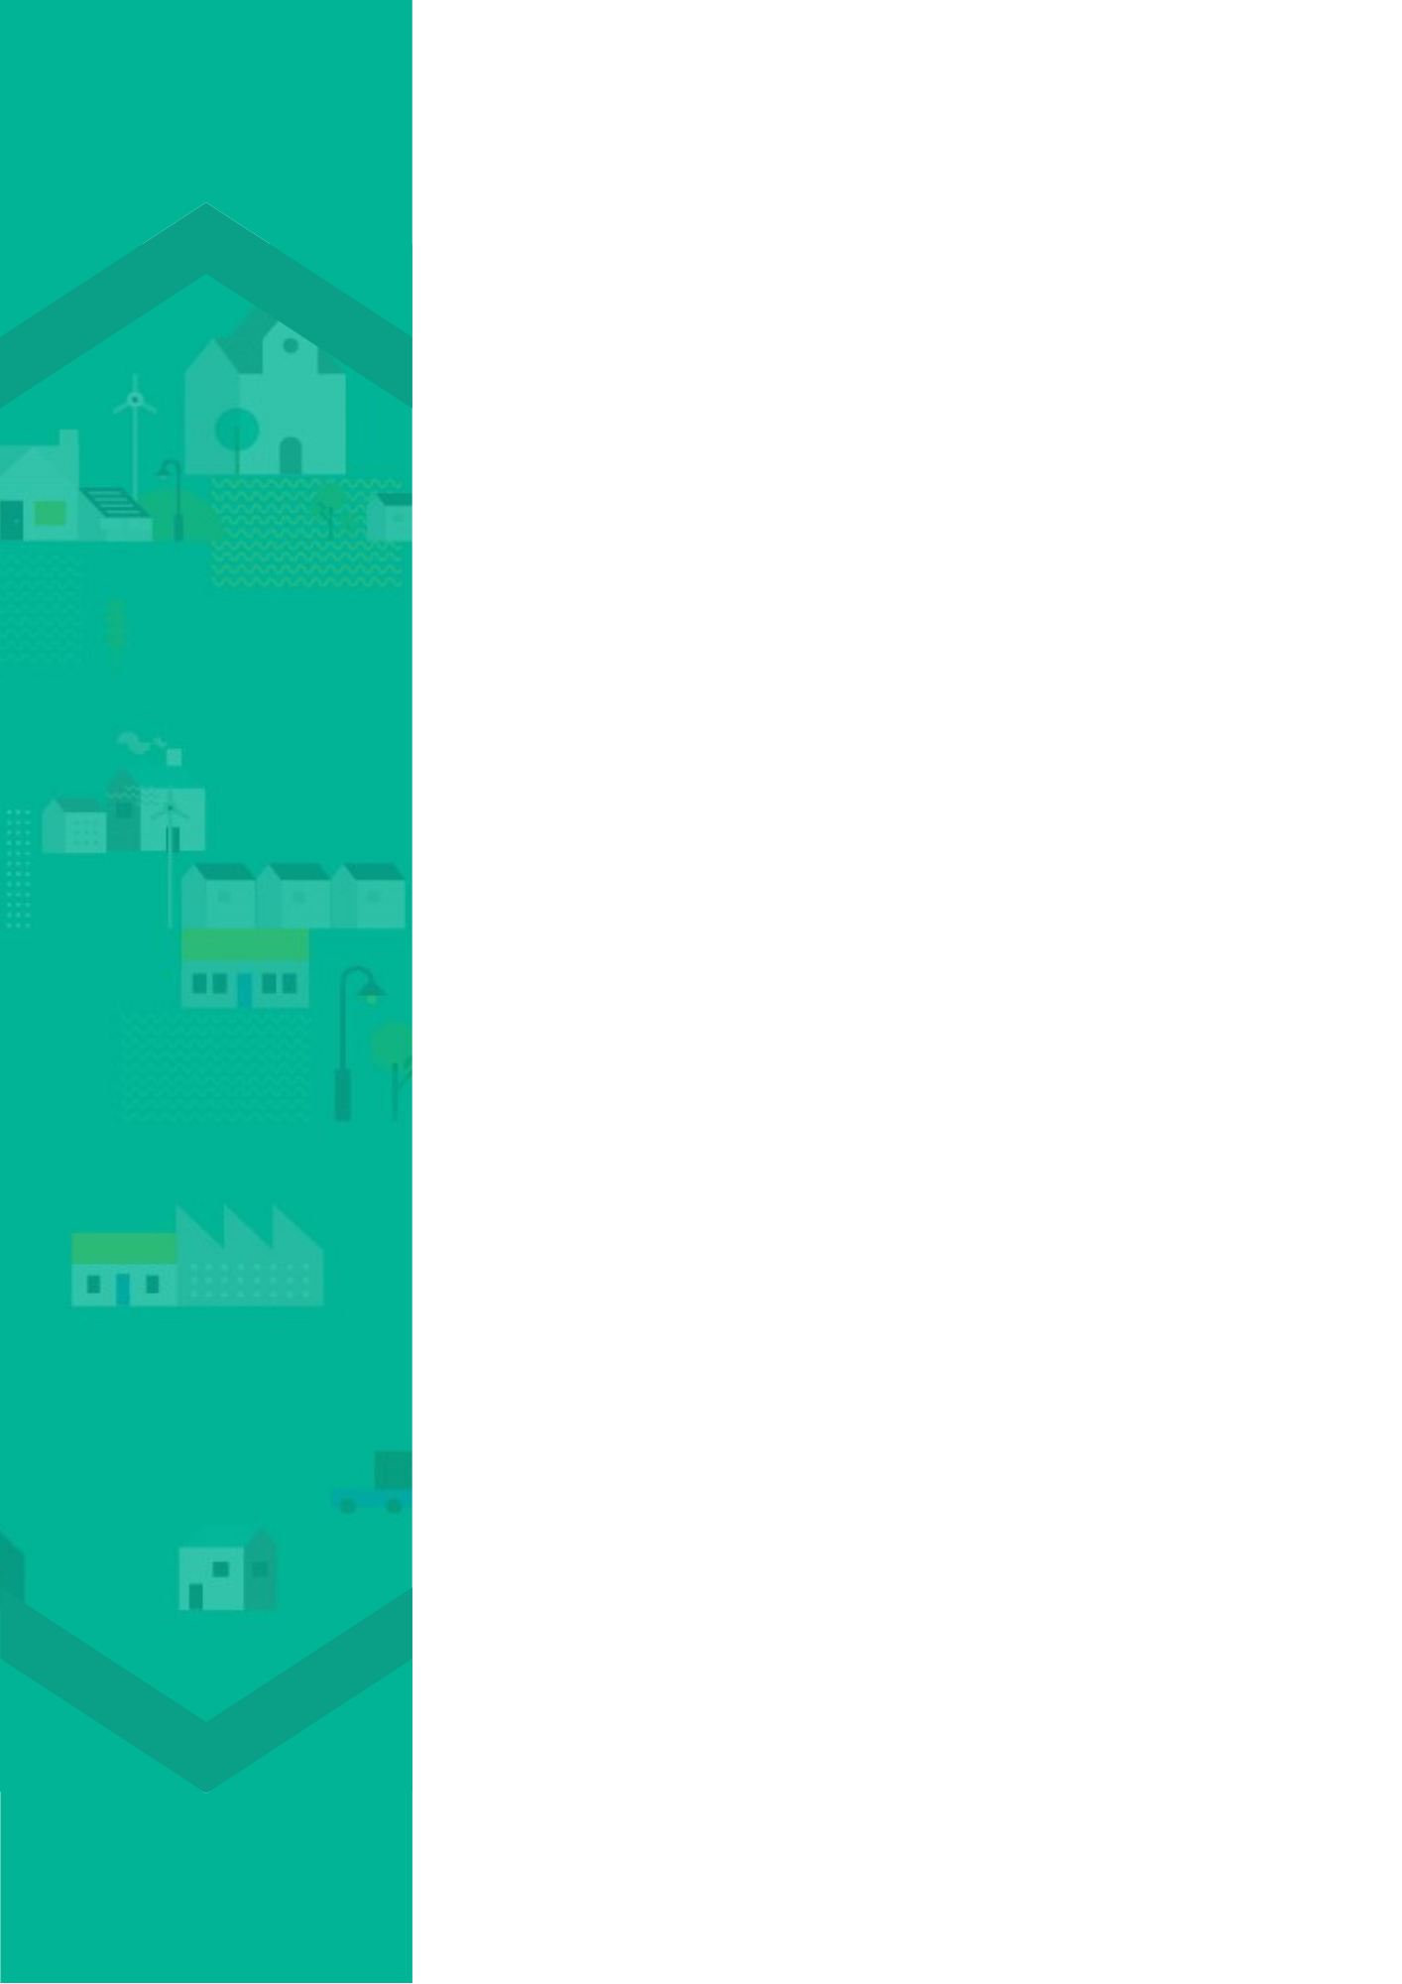

**Alternative template**